Summary Report on Surveys
1.Introduction
BPCs do believe in the importance of feedbacks of its stakeholders. So, many types of surveys are used to investigate the stakeholders’ satisfaction levels about various institutional activities in order to support the decision making process toward enhancing these satisfaction levels which actually means improvement actions have reached the planned goals.
2.Types of applied surveys
The surveys applied in BPCs are listed as following:
- Course evaluation survey (students).
- Program evaluation survey (students in last year of the program).
- Student experience survey (students in middle levels).
- Alumni survey.
- Employers’ survey.
- Electronic services survey (students, teaching staff) designed by quality center.
- Institutional and program activities survey (students, teaching staff) designed by quality center.
- Students’ opinion survey designed by quality center.
- Teaching staff opinion survey designed by quality center.
Some of the questionnaire models used in the mentioned surveys is provided by the national center for academic accreditation evaluation (NCAAA) and the others are designed by the center of quality and development in BPCs as mention above.

3. Process of applying surveys
The process of applying different surveys may be listed as follows:
- Determination of questionnaire models to be used in different surveys.
- Conducting the approved questionnaire models to the targeted sample of stakeholders.
- Collecting data provided by the targeted sample.
- Analyzing data to obtain results.
- The obtained results are to be used in calculating KPIs actual values
- Based on the obtained results, improvement actions are taken and executed.
In Institutional and program activities survey, we use questionnaire models that have been designed by the quality center in BPCs. Here we will demonstrate the process of applying this survey in college of engineering and information technology as an example.
3.1Procedure of applying institutional and program activities survey:
- Two questionnaire models have been developed to be filled by students and teaching staff members.
- The statements in both questionnaires have been classified into a set of domains as shown below:
Table 1
 | Students’ questionnaire | Teaching staff questionnaire
Domains | - Vision & mission. | - Vision & mission.
Domains | - Learning & teaching. | - Governance & Administration.
Domains | - Equipments & facilities. | - Teaching Staff.
Domains | - Services. | - Learning & teaching.
Domains | - Learning sources. | - Equipments & Facilities.
Domains | - Learning sources. | - Services.
Domains | - Learning sources. | - Learning sources.
Statements | 29 | 31

- The used statements have been selected to help in measuring the key performance indicators KPIs listed by NCAAA as well as those required in QA01 Model for academic programs.
- The students’ questionnaires have been distributed over sample of students in the two programs (115 students in electrical engineering & 47 students in computer engineering). The students have filled the questionnaire models manually under supervision of quality representative to reply on their explanations and clarify the statements.
- The teaching staff questionnaire models have been distributed over all faculties in both programs.
An excel book have been designed for questionnaire data entry and analysis, the analysis includes calculation of average score for each statement for both questionnaire models. Also the students’ and faculties scores in both programs are to be compared.
3.2 Obtained results
The students’ survey results for electrical engineering and computer engineering programs are summarized in table 2 and table 3 respectively. On the other hand, the teaching staff survey results for electrical engineering and computer engineering programs are summarized in table 4 and table 5 respectively.
To verify the results obtained in both questionnaires, the scores of electrical engineering program students have been compared with those of computer engineering program students. Also the scores of electrical engineering program teaching staff have been compared with those of computer engineering teaching staff, both comparison results are summarized in table 7

Table 2
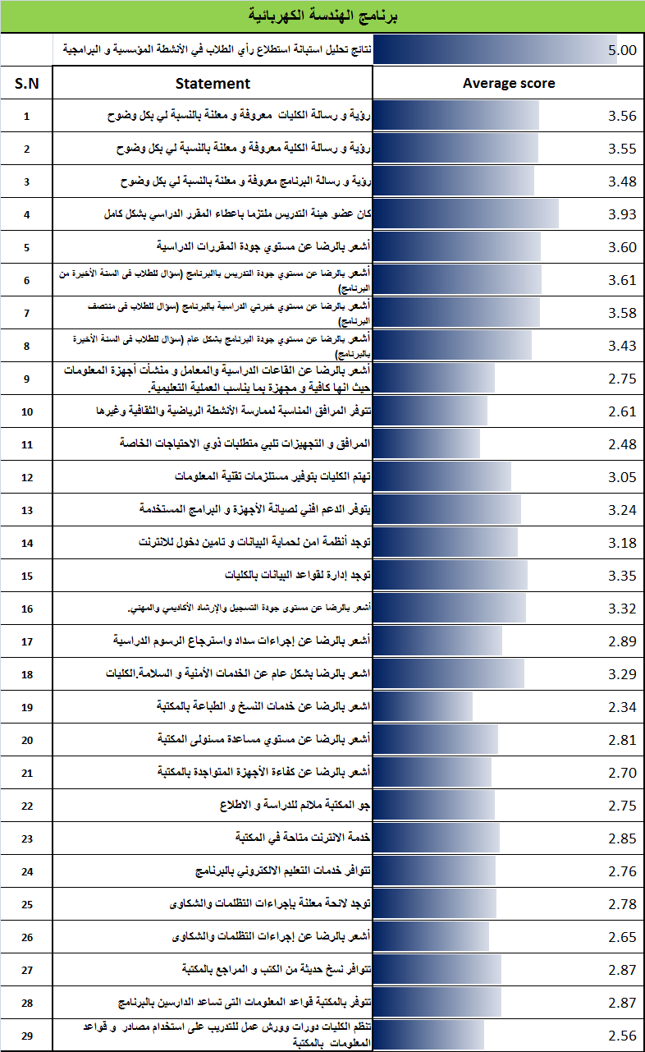

Table 3
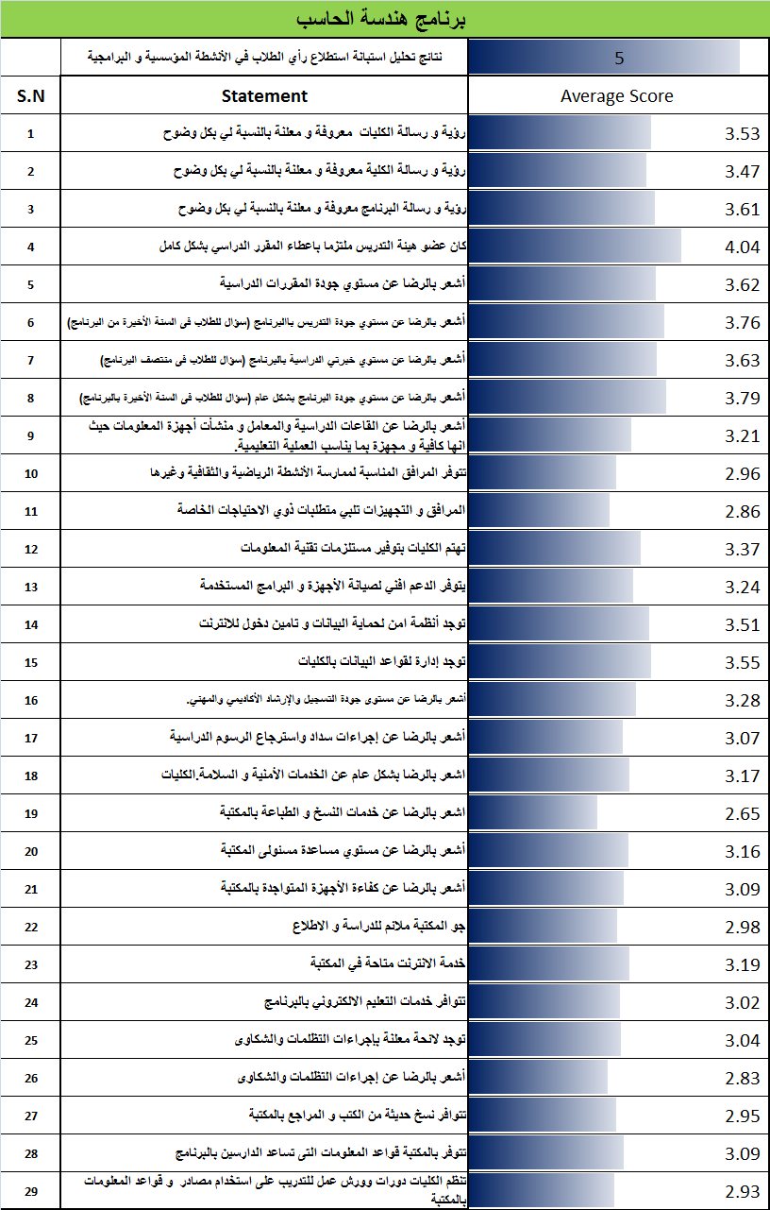
Table 4
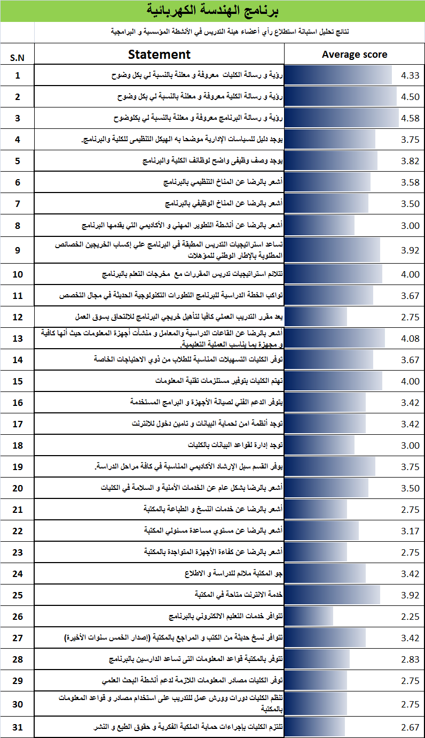

Table 5
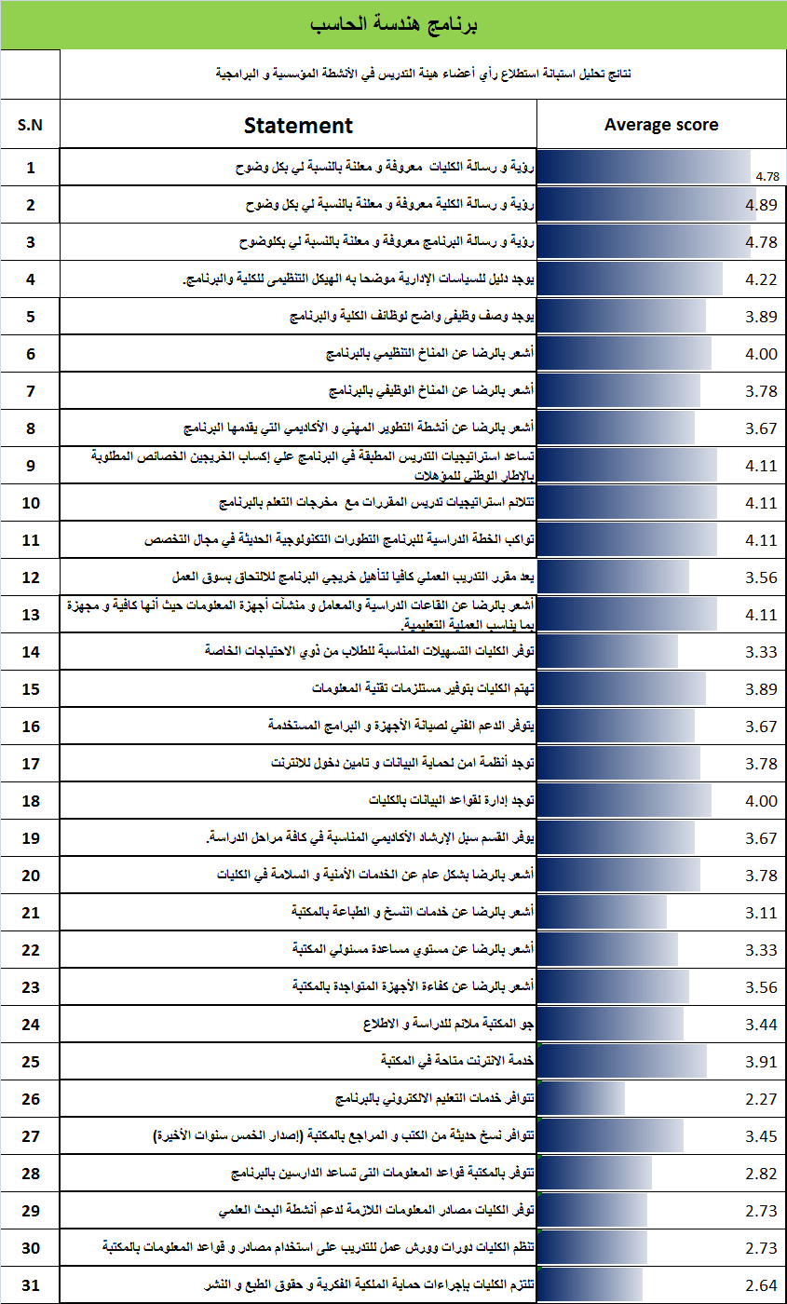

Table 6
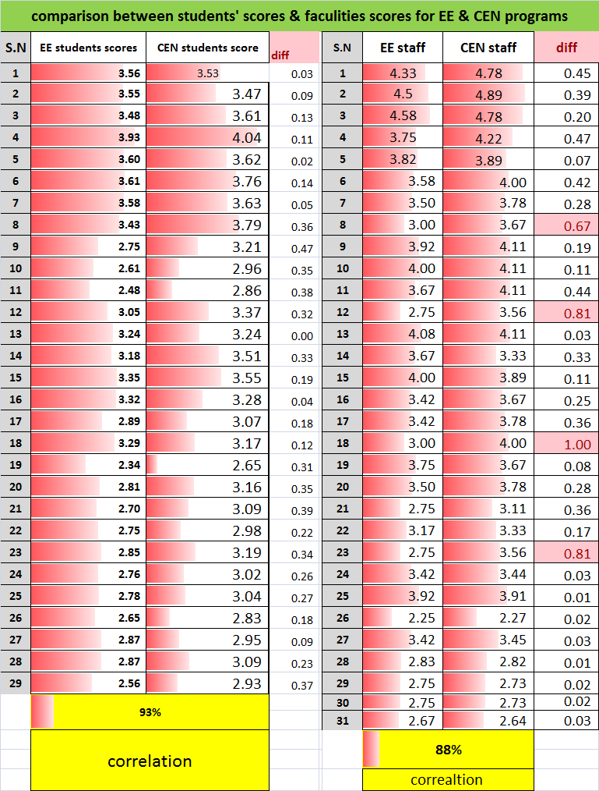

- Relation between KPIs and questionnaire models:

